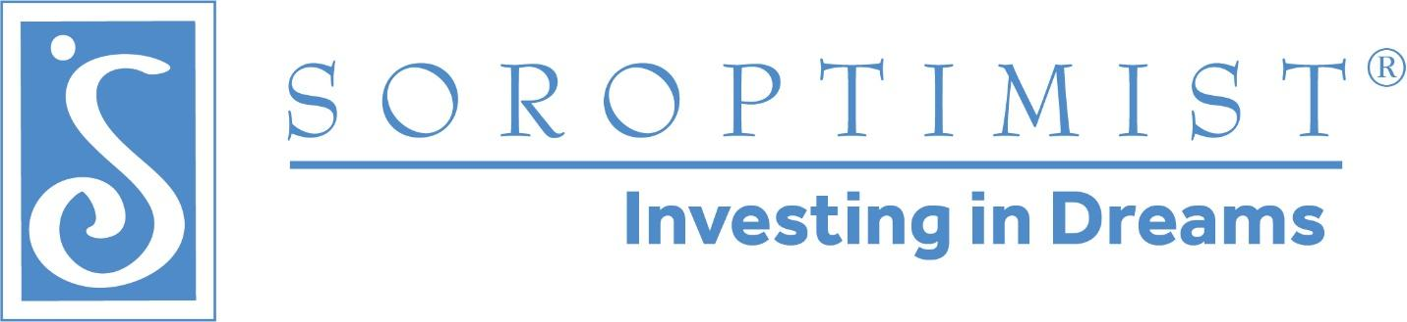

Welcome to {CLUB NAME}!
We are thrilled that you decided to join our team of community-engaged women. Soroptimist is a global volunteer organization that provides women and girls with access to the education and training they need to achieve economic empowerment. Here in {CLUB NAME} we offer multiple opportunities for you to make new friends and volunteer in your local community as we invest in the dreams of women and girls.

Membership
Soroptimist membership celebrates the unique power of women. It is a gift that women give themselves: the chance to help others in an atmosphere of support, friendship, and fun. We look forward to helping you explore the gift of membership as you participate in our club. Once your membership application has been accepted, you will be registered with SIA Headquarters. To gain access to the members-only area of the SIA website (www.soroptimist.org), you must provide an email address unique to you, i.e. not shared.

Getting Started
It can be challenging to know where to start and how to engage when you first join {CLUB NAME}. To learn more about any item outlined below, just contact the relevant committee chair as listed in your club roster of members. If you need help, ask someone on the membership team.

Important Websites
{YOUR CLUB’S NAME WITH LINK TO CLUB WEBSITE}
Soroptimist International
SI of the Americas
SI Western Canada Region
Soroptimist Foundation of Canada
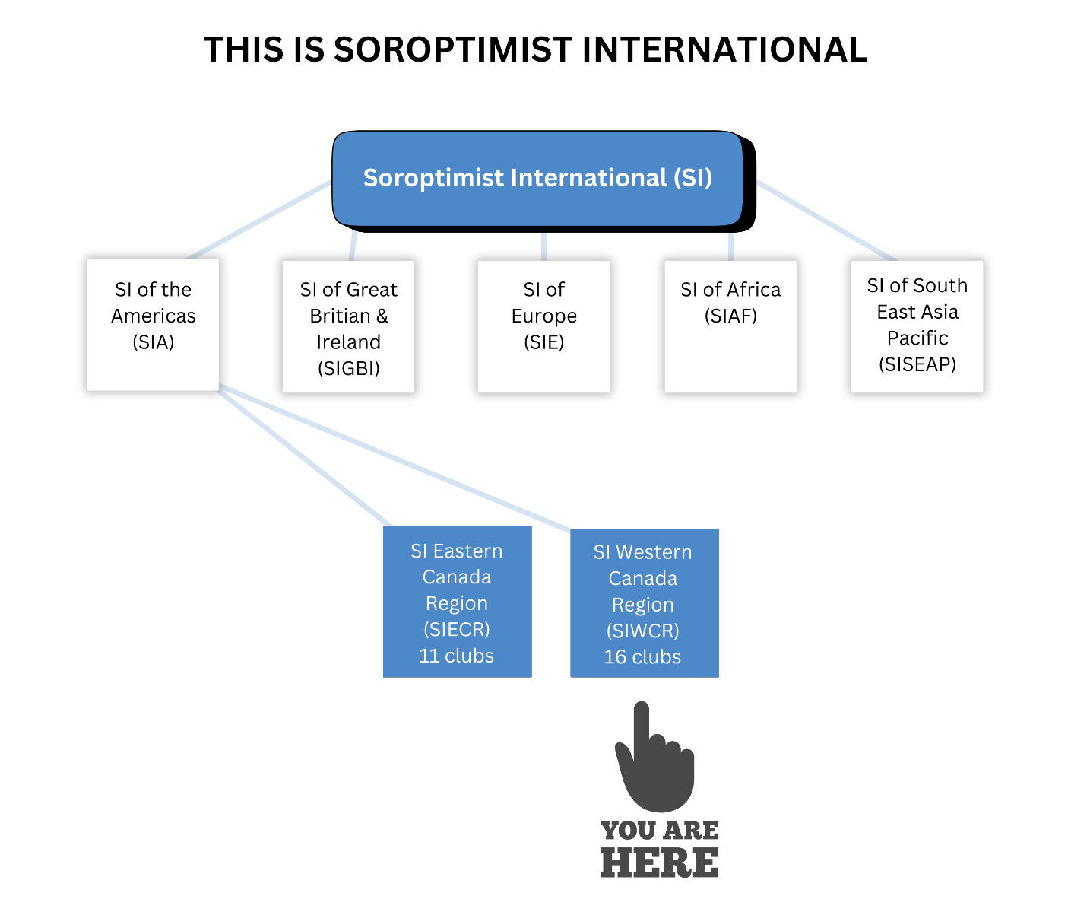
We are part of SI Western Canada Region, which comprises western-located clubs from Manitoba to British Columbia. There are currently 16 clubs and approximately 300 members. Eastern Canada Region comprises Soroptimist clubs in Ontario to the eastern provinces.

What Do We Do? 4 Pillars
Soroptimist activities fall into four categories:
- Fundraising/Philanthropy
- Public Awareness/Brand Recognition
- Membership/Engagement
- Program/Impact
For a club to function well, all four must be strong. We encourage you, as a new member, to become familiar with all four of these pillars and to become involved with at least one. We are a busy club, with no one member expected to be involved with all our projects! Our monthly newsletter has current information about most of them. Let’s look at the four pillars.

Fundraising/Philanthropy
We have numerous projects aimed at improving the lives of women and girls here in {CLUB NAME}. The money to fund these projects is raised through the efforts of our members. Our biggest fundraiser of the year is {EVENT NAME: DESCRIBE THE EVENT}.
Other fundraising initiatives include {LIST OTHER INITIATIVES}, and grant writing.
Sponsorship
Our Sponsorship Committee is busy throughout the year, recruiting new sponsors and maintaining relationships with existing sponsors. Without our generous and supportive community sponsors, we would not be holding our many programs.
We have a loyal cadre of supporters that contribute every year to our programs, and our Sponsorship committee works hard to foster those connections and relationships. But you don’t have to be on that committee to do that work. Maybe you know someone who would be willing to help. Tell them about all the wonderful things we do and ask them if they can contribute.
During the lead up to our events you may want to check with the planning committee or sponsorship committee (to make sure multiple members aren’t approaching the same business or individual and irritating them) but otherwise feel free to solicit funds for our club.
Some of our supporters want to designate their contribution for a specific club program. We absolutely honor their wishes in that regard and earmark those funds for the specified program. In general, however, we do not make a practice of asking for money for one specific program or service.
When you ask someone to support us let them know they are helping us better the lives of girls and women in our community. Tell them our administrative costs are EXTREMELY low. We have no paid staff, no office and almost no administrative costs compared to other non-profits and so they can be assured that their contributions will achieve the maximum benefit.
Other Ways We Fundraise
Host an evening with friends and get everyone to throw some money in a basket. Put together a social event for the club that is fun and raises a bit of money. Maybe your Book Club would support our work. We welcome creativity and initiative in raising funds.
BC Gaming Regulations
Be aware that BC Gaming requires us to apply for a license for activities such as 50/50 draws. We don’t want to run afoul of those rules so if you want to do something like that, please check with a board member for guidance and support.

Public Awareness/Brand Recognition
Our public awareness team is responsible for maintaining our public image in the community, and sharing the Soroptimist mission, via events, media alerts, advertisements, social media, and other initiatives. In addition to our club website, we have active {LIST SOCIAL MEDIA} pages.

Membership/Engagement
The membership team takes care of recruiting and mentoring new members, with a focus on member retention. This includes maintaining an up-to-date member roster with everyone’s photos and contact info. The social committee plans and executes various fun activities for members throughout the year including {EVENT NAME}.

Programs/Impact
This pillar encompasses all of our community programs:

Live Your Dream Award (LYD) Education & Training Awards for Women
This is a signature program of Soroptimist International of the Americas (SIA), the Federation we belong to. It is a financial award for women who provide the primary financial support for their family while enrolled in a post-secondary educational program. Every year, we give {amount of dollars} to LYD Award recipients in our community.

Dream It Be It: Career Support for Girls (DIBI)
This is another signature program of Soroptimist International of the Americas (SIA). Soroptimist clubs work in partnership with girls in small groups or a conference setting to provide them with the information and resources they want and need to be successful in their future careers. SIA headquarters has provided a seven-module curriculum. Our club has implemented DIBI in several ways.
{DESCRIBE DIBI ACTIVITIES, an example from SI TriCities: The first version, for three years, was a two-day conference in the summer where we presented the SIA curriculum plus introduced panels of women from a variety of careers. What the girls told us they liked best was the chance to speak with the women and ask questions. Our second version of DIBI has been a one-day conference in a career-day format, with multiple women mentors available for the girls to chat with. We also have a keynote speaker, plus a panel discussion among a few of the mentors. We have done this twice so far, in 2019 and 2022 and plan to repeat it in the Fall of 2025.}

Other Programs
{DESCRIBE THE OTHER CLUB PROGRAMS. Example:
No Barriers. Period. We regularly collect period products for distribution to women in our community who cannot afford them. Joy’s Place and Westminster House are transition/recovery houses for women where some of our members visit monthly for an evening of crafts and conversation with the women and crafts for their children. Warm Place for Women is a monthly dinner and social evening for women in need in the Tri Cities. Now in its 17th year, Warm Place offers the opportunity for community, friendship, and mentorship while guests enjoy a hot meal, friendly faces, activities, door prizes and have a chance to shop for free gently used clothes. Warm Place for Women takes place on the first Thursday of every month, 4:30 – 8:00 pm at the Kinsmen Hall, 2175 Coquitlam Avenue, Port Coquitlam. This project, unique to our club, attracts much community support.}

New Projects
Are you passionate about something and want to suggest it as a new project for the club? Feel free to suggest it to the Board, with the following information:
- Does it meet our mandate of investing in the education of women and/or girls?
- What kind of budget will it require?
- How much time do you anticipate will be needed?
- How many members will it involve?
Contact the Club Board by emailing {EMAIL ADDRESS}

Club Housekeeping

Criminal Record Checks
Criminal Record Checks (CRC) are a membership requirement and must be renewed a minimum of every five years. Some Soroptimist programs may require more frequent CR checks. CRCs (to work with vulnerable communities and children) are conducted through the BC Department of Justice, free of charge to members. An {CLUB NAME} account number is required, available through our Membership Chair. CRCs through RCMP or local police departments are also accepted.

Club Member Roster
Our {CLUB NAME} Membership team maintains an up-to-date roster of all {CLUB NAME} members’ photos and contact information. This information may only be used for club business. If you move, change your email or phone numbers, please provide the updated information to the Membership Chair so that the roster can be updated.
You should also update your profile on the members-only section of the SIA website, found here https://www.soroptimist.org/for-clubs-and-members/for-members/update-profile.html.

Club Monthly Meetings
Monthly meetings are where we plan our programs, discuss the business of the club, and form friendships. They are held {FREQUENCY example: On the first Thursday of the month} from {TIME-TIME}. {LIST EXCLUSION MONTHS example: except July and August}. Most members come a little early (around {TIME}) to socialize before the meeting. Members are expected to attend meetings in person if possible. Zoom access is provided for those unable to attend in person. Contact the club President for the Zoom link. Currently, meetings are held {LOCATION AND PARKING INFO}. While there are no business meetings in {EXCLUSION MONTHS}, there are often social get-togethers, such as a potluck held at a member’s home.

Club Newsletter
{FREQUENCY example: Once a month}, the club produces a newsletter and distributes it to all members via email. It provides members with committee updates on all projects and other news. If you have something to share that you think club members would like to know about, but it is not strictly Soroptimist business, the newsletter is the preferred method to share that information. For example, if you belong to another community group and it is holding an event you think the Soroptimists would be interested in, share it in the newsletter. A note goes out every month saying when submissions are due, so make sure to get your submission in before the deadline.

Club Membership Year & Club Fees
The Soroptimist membership year runs from July through June. Membership fees are due by {DATE}. You will receive an invoice from the Club Treasurer in advance. Payment can be made via e-transfer. Payment plans are available upon request to the Membership Chair. New members joining mid-club year, will have their fees pro-rated.
Members are encouraged to purchase tickets to club events as well as participate in 50/50 draws and other fund-raising activities. Some projects are not sponsored by the club but by individual members who choose to participate. Participation is optional.

Email Etiquette
We have {NUMBER} members in {CLUB NAME}. The Club Secretary usually sends information to all members. When you receive an email from her or from another member that is addressed to multiple people, and you need to respond, unless specifically asked to do so, do not reply all !

Social Media
You can follow SI Western Canada Region on social media at https://www.facebook.com/wcsoroptimist and by joining the Facebook group “Soroptimist Western Canada Members” https://www.facebook.com/groups/wcrmembers.
You can also follow {CLUB NAME} on social media on {LIST FACEBOOK, TWITTER, INSTAGRAM, BLUESKY, LINKEDIN ACCOUNTS}.

Board of Directors
{CLUB NAME} operates with a Board of Directors consisting of:
- President
- President-Elect
- Vice-President
- Secretary
- Treasurer
- Directors-at-large (2)
- Past-President (The Past-President does not have voting rights)
Elections are held annually in {MONTH}. Check the club roster, updated regularly by the Membership Chair, for photos of the current Board members.

Board Roles
President
A Soroptimist club president is charged with ensuring that the club supports SIA’s mission to improve the lives of women and girls, in local communities and throughout the world. An effective president understands the importance of her role to motivate, manage and move forward. She also realizes that her responsibilities cannot be accomplished without the participation and commitment of others, and therefore facilitates teamwork and employs the expertise and talent of all members. The combination of members’ unique and diverse voices, skills and resources is what makes Soroptimist strong and enables clubs to collectively accomplish our mission. The President develops the agendas (with input from her Board), and chairs board and business meetings. Core competencies and skills include leadership, team building, communication, decision making, time management, strategic planning and the ability to inspire club members.
President-Elect
The President Elect is preparing to take over the position of the president after the current president vacates the office. She works closely with the president to motivate the club and move it forward in the club goals. She performs president responsibilities when the president is not available and works closely with the president and other board members in a leadership capacity. Core competencies and skills include leadership, team building, communication, decision making, time management, strategic planning, and the ability to inspire club members.
Vice President
The Vice President performs president responsibilities when the president or president–elect is not available and works closely with the president and other board members. Core competencies and skills include leadership, communication, decision-making, time management, and ability to execute on plans and serve as a contributing team member.
Secretary
The Secretary works with the President to ensure the meeting agendas (and Treasurer reports if provided) are distributed on time. She records and maintains minutes of board and business meetings. She ensures minutes are distributed to members shortly after each meeting. Core competencies include strong computer skills and the ability to use word processing software, typing, organizational skills, attention to detail, record-keeping, time management, strong written skills and the ability to serve as a contributing team member.
Treasurer
The Treasurer manages the finances for the club. She receives, records and deposits all funds and provides financial reports to the board and members on a monthly, and as requested, basis. She pays bills for authorized expenditures provided in the club’s budget and leads the finance committee and assists with the preparing of the annual financial statements, including the annual budget. Core competencies include ability to use QuickBooks, detailed record keeping, financial knowledge and the ability to serve as a contributing team member.
Director-at-large (2)
The Director regularly attends board meetings and related meetings. She participates actively in committee work. She volunteers for and willingly accepts assignments and completes them thoroughly and on time. Core competencies include strong interpersonal skills, the ability to serve as a contributing team member and a willingness to learn.

Nomination & Election Process
A Nominating Committee is formed in February of each year. The committee is comprised of three members. The current President chooses the Chair of the committee, while the Directors and members choose one each. No more than one person on the nominating committee may be on the current Board of Directors. The Nominating Committee presents the slate of offices at the {MONTH} Business Meeting. The Nominating Committee will invite members to suggest names for consideration and will contact all club members to ask if they want to be nominated. The committee will nominate one or more candidates for each office. Consent from the nominee must be obtained before the name is placed in nomination. Elections take place at the April Business Meeting. Members vote by written ballot or by secure electronic means. If only one member in good standing is nominated to a position, election to that position is by acclamation. The new board is installed at our AGM in June.

Soroptimist Conventions & Conferences

Soroptimist International (SI)
SI hosts a four-day convention for Soroptimists from around the globe, taking place every four years in odd-numbered years. The convention rotates among the federations. In 2023, SI Great Britain & Ireland hosted the convention in Dublin on July 27 to 30th. In 2027, SI Europe will host the convention (location to be determined).

Soroptimist International of the Americas (SIA)
SIA hosts a convention every two years. The next one will be held in 2026 in South Korea. {CLUB NAME} pays a mandatory registration fee for a convention delegate, so the member appointed has her registration paid for.

Soroptimist International Western Canada Region (SIWCR)
SIWCR holds an annual Spring Conference at the end of April or early May for Soroptimist members in Western Canada Region. Location changes from year-to-year. Each club sends 3 voting delegates to Conference, with $50 of each voting delegate’s registration being paid by the club. It is expected that the club president will be one of the delegates. Some clubs like to have the other two delegate spots go to one new member and one experienced member of the club. All other club members are encouraged to attend as non-voting delegates. Our club has a Conference Fund that all members attending WCR Conference can access. Depending on the size of the fund and the number of members attending, each member can have up to {$ AMOUNT} of their expenses for attending Conference reimbursed.

Frequently Asked Questions
As a new Soroptimist Member, you may have some questions about the finances of our club and the organization in general. We have put together a list of frequently asked questions and tried to answer them as best we can. If you have further questions, please reach out to a board member or member of the Membership committee. They will point you in the right direction to find an answer.
Q. Why do I have to pay membership dues? Am I “paying to volunteer?”
A. Early in the history of Soroptimist, the founders of our organization chose to have members fund the major administrative costs through the paying of membership dues so that charitable donations could go to funding programs. Membership dues are what we pay, among other things, for a highly trained staff to do all the administrative work at the federation level so we can spend our time fulfilling the Soroptimist mission to improve the lives of women and girls, locally and around the world.
Q. What do my membership dues pay for?
A. At the Western Canada Region level, your dues help subsidize the cost of running the region, including:
- Having our books audited
- Putting on events like the Gender Equality Now forums, conferences and retreats
- Some of the costs of the Governor being able to visit every club in the region during her biennium.
- Liability insurance that covers the region and all the clubs and is purchased for all the clubs by the region.
- Resources on the SIA website that all members can access.
- Learning materials to help clubs run events, to recruit members, build asocial media strategy or a website.
- The online application portal for the Live Your Dream (LYD) Award.
- Learning and print materials to help run Live Your Dream and Dream it Be It programs.
At the federation level (i.e., Soroptimist International of the Americas), our membership dues pay for member services, governance, and administration. That includes such things as:
- Cost associated with running the elections for the SIA board of directors and the costs of running meetings for those board members (cost of hiring translators, travel, or audio-visual costs associated with virtual or in-person board meetings).
- Keeping track of the rosters of every club in the federation.
- Running monthly reports that go to the governors to that track member statistics for each club. (The region board needs to know these things so we can help clubs that are struggling with membership and welcome new members, among other things).
- Planning biennial conventions for the federation.
- Administering the Club Grants for Women.
- Administering the federation level Live Your Dream Awards and distributing funds for the region level Live Your Dream Awards.
- There is a staff of about 30 people at our headquarters in Philadelphia who are responsible for the smooth running of all that administrative work, and our dues pay their salaries.
- The Live Your Dream Awards given at the federation level (typically 2 to 3winners will receive $10,000 USD).
- The Live Your Dream Awards given at the region level. (The number of awards varies by region based on the total number of club awards given. Western Canada Region currently receives one $5000 USD award and one$3000 USD Award).
- Club Grants for Women (all clubs in the federation can apply for up to$10,000 USD for a Club Grant to fund a club-run local program that benefits women and girls).
Our membership dues pay for the administrative costs to run our organization at the federation and region level. That means that 100% of funds contributed to Club Giving go into funding these programs that benefit women and girls.
Q. Does our club receive any Club Giving money?
A. Our club and the women we serve have directly benefited from Club Giving funds to the tune of {$AMOUNT} for federation Live Your Dream Winners, {$AMOUNT} for region Live Your Dream winners, and {$AMOUNT} for a Club Grant that went towards {DESCRIBE GRANT PURPOSE}. At today's exchange rate, that is almost {$AMOUNT} that has come back to our club or our LYD winners. We are a global organization, and within our own federation we have clubs in countries where the standard of living is much lower than it is in Canada. Funds that we contribute to Club Giving can have a huge impact on a LYD winner in the Philippines, Mexico, or Brazil, for example.
Q. How come I don't have to pay to be a volunteer with Girl Guides or coach hockey or soccer?
A. In those organizations, the participants pay dues that cover the administrative costs, not the volunteers. For most Soroptimist programs, we generally do not charge the people we help so those administrative costs need to be paid for somehow.
Q. {CLUB NAME} has a budget for operating expenses. If our member dues are meant to pay for administrative expenses, what does the money in the operating budget pay for?
A. The membership dues we collect pay for the administrative expenses at the region and federation level. We could raise membership dues to cover the club’s administrative costs, but we feel that making them much higher would be a barrier to membership for many women. Instead, we follow the best practice guidelines for Canadian charities and allocate 10 per cent of the funds our club raises to cover operating expenses. Some of the expenses covered by operating funds on an ongoing basis include:
- Annual fees for our club Zoom Account
- Costs to have brochures and other print materials printed
- Costs for new member name tags
- {Room rental for our business meeting}
- Costs associated with hosting membership recruitment events, or workshops for our members
- Costs for hosting special club celebrations such as major club anniversaries (10-year, 20-year etc.)
- Other occasional expenses such as replacing the club banner, or purchasing AV equipment (speakers, projector, omnidirectional microphone)
Q. Do we have our books audited?
A. Both Western Canada Region and the federation (SIA) have their books professionally audited annually. The federation financial statements are available online at www.soroptimist.org. The region financial statements, as well as the auditor’s report, are included annually in the information package for our Western Canada Region Conference. There is no legal requirement for the club books to be professionally audited, but the books are reviewed each year by an Audit Committee that is appointed by the club board and does not include the current treasurer (details are in our club by-laws).
Q. Do we have guidelines for raising money?
A. As Soroptimists we work very hard to improve the lives of girls and women in our community but to do that costs money, so we also spend a fair bit of energy raising funds. We do not receive ANY government funding and the monies we need to support our programming come from all our collective efforts.
We have a sponsorship committee that does a great job soliciting funds from local businesses and individuals and our annual {EVENT NAME} is an important money maker, but every member can contribute to supporting our club financially. We are not a registered charity and cannot issue tax receipts for contributions. {DESCRIBE HOW PEOPLE CAN DONATE TO YOUR CLUB}. Those funds are dedicated to {PROGRAM NAME} and go towards {PROVIDE DETAILS}.
Q. What is The Soroptimist Foundation of Canada?
The Soroptimist Foundation of Canada (SFC), established in 1963, is a registered charity created by the Soroptimist clubs in Canada. It has over $3M in assets. Board members are elected from clubs in Eastern and Western Canada. Each club has a vote at the Annual General Meeting held in October. The Foundation funds programs related to education for girls and women. Soroptimist clubs in Canada can apply for grants to provide funding for club projects like Dream It, Be It: career support for girls, and other educational programs for teens. The money to fund these programs comes from donations from Soroptimist clubs, individuals, and corporate donors. Donors can receive a tax benefit for their donations.

Get In Touch
Do you have more questions? Please let us know by emailing our club membership chair, {NAME AND EMAIL ADDRESS}.
Welcome to {CLUB NAME}!

